CAMPUS BUY
A

Major Project

Submitted in partial fulfilment for the award of the degree of

MASTER OF COMPUTER APPLICATION
IN
Computer Science & Application


by

Ritik Chaudhary
MCAN1CA24024
Under the guidance of
Ms. Sangita Chakrabarty
Department of Computer Science &Application
School of Engineering and Technology
ITM UNIVERSITY, GWALIOR - 474026 MP, INDIA
(April 2026)

CERTIFICATE

This is to certify that the work titled “CAMPUS BUY ” submitted by “Ritik Chaudhary, (MCAN1CA24024)” in partial fulfilment for the award of the degree of MCA, ITM University, Gwalior has been carried out under my/our supervision.
To the best of my knowledge and belief, the dissertation
(ii) Is an original piece of work of Candidate.
- It has duly been completed.
- It is up to the standard both in respect of contents and language.
- Free from plagiarism
- Work has not been submitted partially or wholly to any other University or Institute for the award of this or any other degree or diploma.

Signature of Guide Signature of Co-guide

Designation Designation

Date Date

DECLARATION

I with this declare that the work entitled “CAMPUS BUY” submitted to the Department of Computer Science Engineering, School of Engineering and Technology, ITM University, Gwalior (M.P.) is our work done under the su- pervision of Ms. Sangita Chakrabarty. The dissertation doesn’t contain any part which has been submitted for award of any degree either in this University or in any other University.
We further declare that the work is free from any plagiarism.

(Signature of the candidates)

(Name of the candidates)
Ritik Chaudhary

(Roll Number of the candidates)
MCAN1CA24024

Verified by guide

Acknowledgement

Firstly, I thank Lord Almighty for making it possible for me to complete this work. The success and outcome of this project required a lot of guidance and assistance from many people, and I am incredibly privileged to have got it all along with the completion of my project. All that I have done is only due to such supervision and assistance and I would not forget to thank them.

I respect and thank Ms. Sangita Chakrabarty for providing us an opportunity to do project work and giving us all support and guidance which made us complete the project duly.She took keen interest on our project work and guided us all along and provided all the necessary information for developing a good system.

I would not forget to remember HOD, Mentors,DEAN for his encouragement and more over for his timely support and guidance till the com- pletion of our project work. I heartily thank my guide Ms. Sangita Chakrabarty for their guidance and suggestions during this project work.

At last but not the least we would like to thank our parents who trusted us and helped us through the errand.

Abstract

The recovery and examination of digital data has become a significant part of numerous criminal investigations today. Given the ever-expanding num- ber of individual digital gadgets, for example, journals, tablets, and cell phones, we as a whole accumulate, store, and create an enormous amount of data. A portion of this data might be valuable proof for examination and might be utilized in courts. During the decades, expanding research has been made towards characterizing devices and conventions for the analysis of evi- dence originating from excellent sources. This project attempts to provide an automated solution for the extraction and carving of data from digitally gen- erated dumps or image files of the evidence. This thesis is a balanced mix of manual as well as automated process of file carving, making it suitable for readers of diverse backgrounds.

Contents

CERTIFICATE…………………………………………………………………ii

DECLARATION……………………………………………………………….iii

Acknowledgement……………………………………………………………...iv

Abstract………………………………………………………………………….v

List of Tables……………………………………………………………………ix

Chapter 1………………………………………………………………………...1

Introduction & Objectives

1.1 Introduction
1.2 Objectives

Chapter 2………………………………………………………………………...3

Literature Survey

2.1 Online Marketplace Systems
2.2 Real-Time Communication in Web Applications
2.3 Secure Authentication and Data Management
2.4 Integration of Cloud and Third-Party Services
2.5 Limitations of Existing Systems
2.6 Conclusion of Literature Survey

Chapter 3………………………………………………………………………..5

Research Gap & Proposed System

Chapter 4………………………………………………………………………..7

Technology Description

4.1 SOFTWARE REQUIREMENTS
4.2 HARDWARE REQUIREMENTS

Chapter 5……………………………………………………………………….8

Project Description

5.1 Project Name
5.2 Project Objective
5.3 Features Overview
5.4 Core Modules
5.6 Security Features

Chapter 6……………………………………………………………………….14

6.1 Workflow
6.2 ER Diagram
6.3 Dataflow

Chapter 7……………………………………………………………………….17

Project Screenshot

Chapter 8……………………………………………………………………….21

Results and Discussions

Chapter 9……………………………………………………………………….24

Future Scope

Chapter 10………………………………………………………………………26

Conclusion

References………………………………………………………………………28

List of Abbreviations

API – Application Programming Interface

CSS – Cascading Style Sheets

DB – Database

DNS – Domain Name System

HTML – HyperText Markup Language

HTTP – HyperText Transfer Protocol

HTTPS – HyperText Transfer Protocol Secure

JS – JavaScript

JSON – JavaScript Object Notation

JWT – JSON Web Token

MERN – MongoDB, Express.js, React.js, Node.js

MVC – Model View Controller

NoSQL – Not Only Structured Query Language

OTP – One Time Password

REST – Representational State Transfer

UI – User Interface

URL – Uniform Resource Locator

UX – User Experience

WS – Web Socket

List of Figures & Tables

Figure 1 : Workflow

Figure 2 : ER Diagram

Figure 3: Dataflow

Figure 4 : Landing Page

Figure 5 : Registration Page

Figure 6 : Login Page

Figure 7 : Home Page

Figure 8 : Feedback Page

Figure 9 : Sell Page

Figure 10 : History Page

Chapter 1

Introduction & Objectives

1.1 Introduction

In the modern digital age, the advancement of internet technologies has significantly changed the way people interact, communicate, and perform commercial activities. Traditional methods of buying and selling products are often time-consuming, limited by geographical boundaries, and lack efficient communication between buyers and sellers. With the rise of web-based applications, online marketplaces have become a convenient and effective solution, allowing users to access products and services anytime and from anywhere.

The proposed system, Buy & Blast, is an online marketplace platform designed to simplify the process of buying and selling products. The system provides users with an easy-to-use interface where they can register, log in, and manage their product listings efficiently. One of the key features of this system is the integration of real-time communication using chat functionality, which enables direct interaction between buyers and sellers. This feature helps in improving transparency, building trust, and facilitating faster decision-making.

The project is developed using modern web technologies, following a full-stack development approach. The frontend ensures a responsive and interactive user experience, while the backend handles data processing, authentication, and communication with the database. Additional features such as image upload, notifications, and message control further enhance the usability of the system. The primary aim of this project is to provide a secure, efficient, and user-friendly platform that combines marketplace functionality with real-time interaction.

1.2 Objectives

The main objective of the proposed system is to develop a comprehensive and efficient online marketplace platform that enables users to buy and sell products seamlessly. The system aims to provide a secure environment where users can register, authenticate, and manage their accounts without any difficulty. Another important objective is to implement real-time communication between users through chat functionality, which enhances interaction and improves the overall user experience.

1

The project also focuses on providing complete product management features, allowing users to add, update, and delete product listings along with uploading images for better representation. Ensuring data security and integrity is another key objective, which is achieved through the implementation of authentication and authorization mechanisms. Additionally, the system aims to incorporate features such as message control, where users can delete messages within a specific time frame, and notification services to keep users informed about important updates.

Furthermore, the project is designed to deliver a responsive and interactive user interface using modern frontend technologies, ensuring compatibility across different devices. Efficient data handling and storage are also emphasized to maintain system performance and reliability. Overall, the objective is to create an integrated platform that enhances user interaction, improves efficiency, and provides a reliable solution for online buying and selling activities.

2

Chapter – 2
Literature & Survey

S.No | Author / Year | Title / System | Methodology / Technology Used | Key Findings / Contribution | Limitations
1 | Smith et al. (2020) | Online Marketplace Systems | Web-based architecture using HTML, CSS, JavaScript, and SQL databases | Developed a basic online marketplace for buying and selling products with structured data storage | Did not support real-time communication or dynamic updates
2 | Kumar & Singh (2021) | E-Commerce Web Application | MERN Stack (MongoDB, Express.js, React.js, Node.js) | Demonstrated efficient full-stack development with REST APIs and user authentication | Lacked live interaction between buyers and sellers
3 | Lee et al. (2022) | Real-Time Chat Application | Node.js with Socket.IO and WebSockets | Enabled instant message delivery and bidirectional communication | Focused only on chat, no integration with product systems
4 | Sharma et al. (2021) | Classified Advertisement System | PHP, MySQL, and Bootstrap framework | Allowed users to post ads and browse listings | No real-time chat or notification system
5 | Patel & Jain (2023) | Secure Authentication Mechanism | JWT (JSON Web Token), bcrypt hashing | Improved login security and session management | Limited to authentication module only
6 | Brown et al. (2022) | Email Notification System | Nodemailer with SMTP (Gmail server) | Provided automated email alerts for user activities like registration and updates | No integration with live system events
7 | Gupta et al. (2023) | Full Stack Marketplace Platform | MERN Stack with Cloudinary for media storage | Enabled scalable product listing with image upload and cloud storage | No support for message control or deletion
8 | Zhang et al. (2021) | Real-Time Web Communication Systems | WebSockets and Socket.IO protocol | Reduced latency and improved communication efficiency | Required additional backend integration
9 | Verma & Arora (2022) | User Feedback Management System | REST APIs with MongoDB database | Allowed structured feedback storage and retrieval | No real-time or chat-based feedback
10 | Chen et al. (2022) | Scalable Web Applications | Microservices architecture with Node.js | Improved scalability and modular design | Complex implementation for small-scale projects
11 | Roy et al. (2023) | Online Buy & Sell Platform | React.js frontend with Firebase backend | Provided quick deployment and real-time database support | Limited customization and control compared to MERN
12 | Ahmed & Khan (2022) | Chat-Based Communication System | Socket.IO with Express backend | Enabled group and private messaging | No time-based message deletion feature
13 | Singh et al. (2023) | Image Handling in Web Apps | Cloudinary API integration | Efficient image storage and optimization | Dependent on third-party service
14 | Mehta et al. (2021) | RESTful API Design | Node.js and Express.js | Standardized API communication between client and server | No real-time capabilities
15 | Your Proposed System | Buy & Sell Web Application with Real-Time Chat | MERN Stack + Socket.IO + Nodemailer + Cloudinary | Integrates product marketplace, real-time chat, secure authentication, email notifications, and message deletion within time limit | Can be further improved for scalability and advanced features

4
Chapter – 3
Research gap & Proposed system

3.1 Research Gap

From the detailed study of existing online marketplace systems, it has been observed that although these platforms provide essential functionalities such as product listing, searching, and basic transaction support, they still suffer from several limitations. One of the major gaps is the lack of efficient real-time communication between buyers and sellers. Many existing platforms rely on delayed messaging systems or external communication channels, which reduces the speed of interaction and affects the decision-making process of users.
Another significant issue is the lack of integration of key features within a single platform. In many systems, functionalities such as authentication, product management, communication, and notifications are either partially implemented or not well connected. This results in a fragmented user experience and reduces overall system efficiency. Additionally, many platforms do not provide advanced features like message control, real-time updates, or personalized user interaction, which are essential for modern applications.
Security is also a major concern in existing systems. Some applications do not implement strong authentication and authorization mechanisms, making them vulnerable to unauthorized access and data breaches. Furthermore, issues related to data consistency, storage efficiency, and scalability are often not properly addressed, which can lead to performance degradation as the number of users and data increases.
User experience is another area where many systems fall short. Complicated interfaces, lack of responsiveness, and limited interactivity reduce user engagement. These limitations clearly indicate the need for a more advanced, integrated, and user-centric system that not only provides marketplace functionality but also ensures secure, real-time, and efficient communication.

5

3.2 Proposed System

To overcome the identified research gaps, the proposed system Buy & Blast is designed as a modern and fully integrated online marketplace platform. The system aims to combine all essential features into a single application, providing users with a seamless and efficient experience. It allows users to register, authenticate securely, and manage their accounts with ease while ensuring data privacy and protection.
One of the key features of the proposed system is the integration of real-time communication using advanced web technologies. This enables users to interact instantly through chat, allowing them to discuss product details, negotiate prices, and make informed decisions without delays. This feature significantly enhances user engagement and builds trust between buyers and sellers.
The system also provides comprehensive product management functionalities, including adding, updating, and deleting product listings along with image uploads for better presentation. Integration with cloud-based services ensures efficient storage and retrieval of media files. Additionally, notification features are included to keep users informed about important activities such as new messages or product updates.
From a technical perspective, the system is developed using a full-stack approach, ensuring a responsive frontend, efficient backend processing, and reliable database management. Proper validation, error handling, and security measures are implemented to maintain system integrity and performance. The design also considers scalability, allowing the system to handle an increasing number of users and data efficiently.
Overall, the proposed system aims to provide a secure, scalable, and user-friendly platform that not only addresses the limitations of existing systems but also enhances the overall experience of online buying and selling through improved interaction, functionality, and performance.

6

Chapter – 4
Technology Description

4.1 SOFTWARE REQUIREMENTS

41.1 VS Code Editor
Visual Studio Code is used as the primary IDE for frontend and backend development. It supports extensions for React, ESLint, Prettier, and Docker which streamline development and maintain code quality.
4.1.2 GitHub
GitHub hosts the project repository and is used for version control, issue tracking, and CI/CD (GitHub Actions). GitHub Pages (for static demo pages) or the repository README provide project documentation.
4.1.3 Node.js & npm
Node.js is the server environment while npm manages project dependencies. Express.js runs the REST API.
4.1.4 MongoDB
MongoDB (Atlas) stores users, listings, messages, and reports as document collections. Mongoose is used for schema validation and ODM functionality.
4.1.5 Cloudinary
Cloudinary handles image uploads, transformations (thumbnails, resizing), and serves media via CDN for fast page loads.
4.1.6 Socket.IO
Socket.IO implements realtime chat and notification channels so users can negotiate listings live.

4.2 HARDWARE REQUIREMENTS

4.2.1 Minimum requirements for development machines:
- 4 GB RAM (recommended 8 GB)
- 20 GB free disk space
- Intel i3 / AMD Ryzen 3 (or better) and Stable internet connection for deploying and testing cloudservices.

7

Chapter - 5
Project Description

5.1 Project Name
CampusBuy — Campus Exclusive Buy & Sell Platform
CampusBuy is a secure, student-focused marketplace created specifically for the verified students of ITM UNIVERSITY, GWALIOR. It serves as a digital platform where students can buy, sell, or exchange second-hand items such as books, electronics, lab equipment, furniture, and other essentials used in daily academic and hostel life.
The system bridges the communication gap between buyers and sellers by providing a single, safe, and moderated environment within the university ecosystem. Its purpose is not only to promote affordability and convenience but also to encourage sustainability through reuse and recycling of goods within the campus.

5.2 Project Objective
The main objective of CampusBuy is to develop a trusted, efficient, and user-friendly marketplace restricted exclusively to the verified students of ITM University Gwalior. The platform aims to overcome the common issues students face when using public e-commerce or classified websites such as OLX or Facebook Marketplace — issues like fraud, fake listings, and meeting strangers outside the campus. By enforcing institutional email verification, CampusBuy ensures that every participant belongs to the ITM University community, making interactions safer and more reliable.
CampusBuy is designed with several goals in mind:
- To provide an intuitive interface that allows students to easily list, browse, and purchase items.
- To enable secure authentication using university email IDs and OTP verification.
- To incorporate real-time communication through an in-built chat system powered by Socket.IO.
- To support media management through cloud-based image hosting for quick and optimized uploads.
Beyond transactional utility, the platform also supports the university’s sustainability objectives by promoting a reuse culture — reducing waste and the environmental footprint of students.

8

5.3 Features Overview
CampusBuy offers a comprehensive set of features focused on usability, performance, and trust.
- Registration & OTP Verification (Institutional Email):
Every user must register using their official college email
ID (e.g., @itm.ac.in) and verify their account via a One-Time Password (OTP). This step guarantees that all users are verified members of ITM University, ensuring a safe and restricted environment.
- Create & Manage Listings:
Students can post items for sale by uploading up to five images along with the item’s name, description, category, price, and condition. Listings can later be deleted. The process is made quick and mobile-friendly to save time for busy students.
- Search, Filter, and Sort:
A robust search engine allows users to find specific products by applying filters such as price range, product category, and condition. Sorting options like “Low to High” or “High to Low” improve browsing convenience.
- Global Chat feature
CampusBuy provides a Global Chat feature where any verified student of ITM UNIVERSITY, GWALIOR can type their requirements or requests, such as “Need a used calculator” or “Looking for a bicycle,” and other students can reply directly to that message. This creates an open communication space that helps students quickly connect with peers who can fulfill their needs. The Global Chat ensures faster interaction and promotes community engagement within the campus by allowing everyone to communicate in one common chatroom instead of private one-on-one messages.User Profile and History Management:
Each user has a personalized dashboard showing their listings, sold items, and interaction history. They can manage their profile, delete listings, or mark items as sold once a transaction is completed.

Overall, CampusBuy integrates modern technologies like React.js, Node.js, Express.js, MongoDB, and Cloudinary to provide a fast, reliable, and secure experience. It not only simplifies trading among students but also fosters community interaction and sustainability within ITM University.

9

5.4 Core Modules
5.4.1. Authentication Module
Purpose: Secure user registration and login with ITM University email verification Features:
- OTP-based email verification (only @itm.ac.in emailsallowed)
- JWT token-based authentication
- Password reset functionality with OTP
- Profile management with image upload
- Secure password hashing with bcryptjs

Key Components:
- authController.js: Handles OTP generation, verification, login,and password reset
- authMiddleware.js: Protects routes requiring authentication
- User.js & TempUser.js: User data models

Workflow:
- User registers with ITM University email
- OTP sent to email for verification
- Temporary user data stored in TempUser collection
- After OTP verification, user moved to permanent Usercollection
- JWT token generated for authenticated sessions

5.4. 2. Product Management Module
Purpose: Enable users to create, view, and manage product listings
Features:
- Product CRUD operations (Create, Read, Update, Delete)
- Multiple image upload with Cloudinary integration
- Product categorization and condition specification
- Price negotiation options
- User-specific product management
- Real-time product updates via Socket.io

10
Key Components:
- productRoutes.js: API endpoints for product operations
- Product.js: Product data model
- Cloudinary integration for image storage

Workflow:
- Authenticated users can create product listings
- Images uploaded to Cloudinary and URLs stored
- Products displayed with user information
- Real-time updates broadcast to all connected clients
- Users can manage their own product listings

5.4.3 Real-time Chat Module
Purpose: Facilitate communication between buyers and sellers Features:
- Real-time messaging using Socket.io
- Message reply functionality
- WhatsApp number sharing
- Message deletion within 1-hour time limit
- Persistent message storage in MongoDB

Key Components:
- Message.js: Message data model
- Socket.io integration in index.js
- Real-time event handling for message operations

11
Workflow:
- Users connect via Socket.io
- Messages broadcast to all connected clients
- Messages stored in MongoDB for persistence
- Users can reply to specific messages
- Message deletion allowed within 1-hour window

5.4.4. Feedback System Module
Purpose: Collect user feedback for platform improvement Features:
- Structured feedback collection (rating, likes, improvements)
- Email notification system- Feedback form validation

Key Components:
- feedbackController.js: Handles feedback processing
- Feedback.js: Feedback data model (if needed for storage)
- Nodemailer integration for email notifications

Workflow:
- Users submit feedback through the feedback form
- Feedback data validated and processed
- Email sent to admin with feedback details

5.5 Database Schema

5.5.1 User Model { email: String (required, unique, @itm.ac.in only), name: String, password: String (hashed), otp: String (temporary), otpExpires: Date (temporary), branch: String, whatsapp: String, profileImage: String (default placeholder), resetPasswordOtp: String, resetPasswordExpires: Date

12
5.5.2 Product Model
{
title: String, description: String, category: String, condition: String, price: Number, negotiable: Boolean, images: [String] (Cloudinary URLs), user: ObjectId (reference to User), createdAt: Date (default: Date.now)
}

5.5.3 Message Model
{
text: String (required), sender: String (default: "Anonymous"), senderImage: String (default placeholder), whatsappNumber: String, replyTo: ObjectId (reference to Message), timestamp: Date (default: Date.now)
}

5.6 Security Features
- Email Domain Restriction: Only @itm.ac.in emails allowed
- OTP Verification: 6-digit OTP with 10-minute expiry
- JWT Authentication: Secure token-based authentication
- Password Hashing: bcryptjs with salt rounds
- CORS Configuration: Restricted to specific origins
- File Upload Security: Image type validation and size limits

13
Chapter – 6
6.1 Workflow

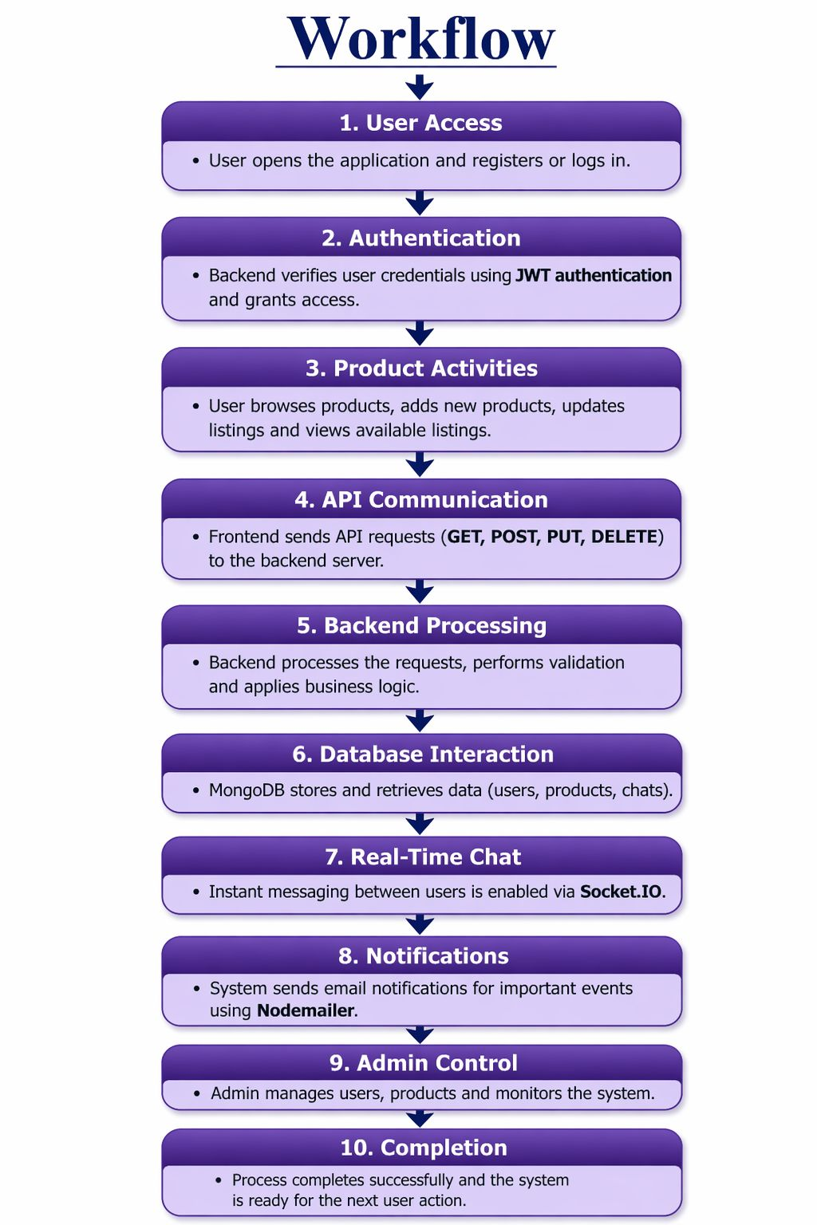

14
6.2 ER Diagram

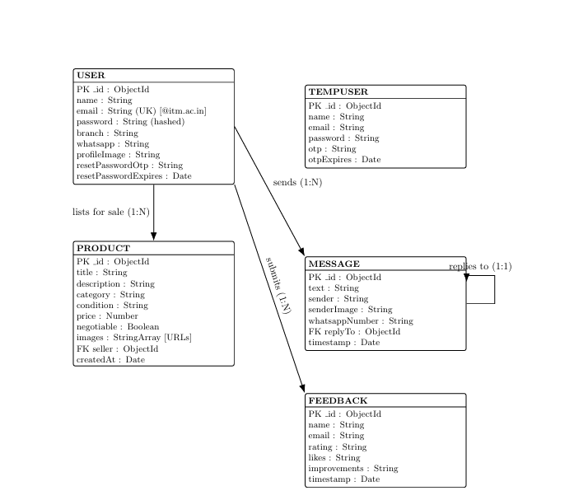

15

6.3 Dataflow

The data flow of the “Buy & Blast” application begins when the user provides input such as login details, product data, or messages through the frontend. The React-based frontend validates the input and sends it to the backend via API requests. The backend processes the request, performs authentication, and interacts with the database to store or retrieve data. For real-time features like chat, Socket.IO enables instant communication between users. After processing, the backend sends a response back to the frontend, which updates the user interface accordingly. This cycle continues to ensure smooth and efficient system operation.

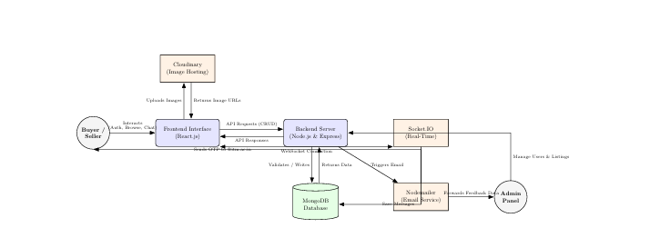

16
Chapter – 7
Project Screenshot

7.1 Landing Page

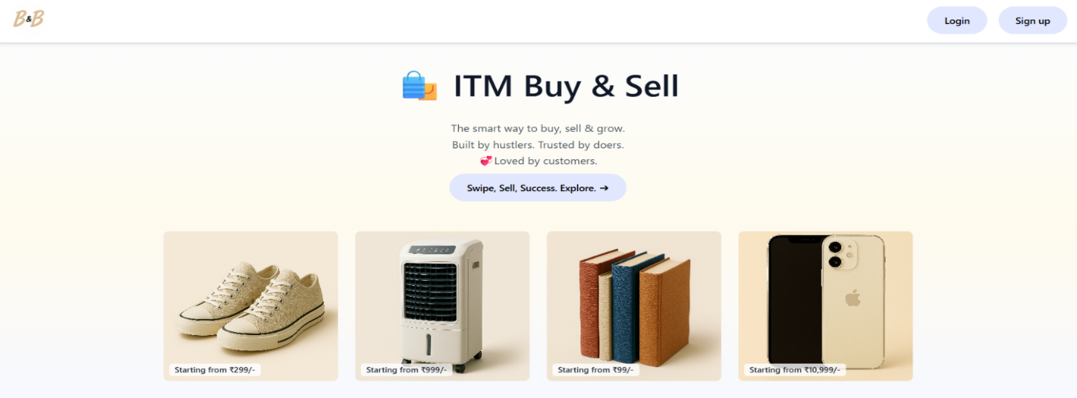

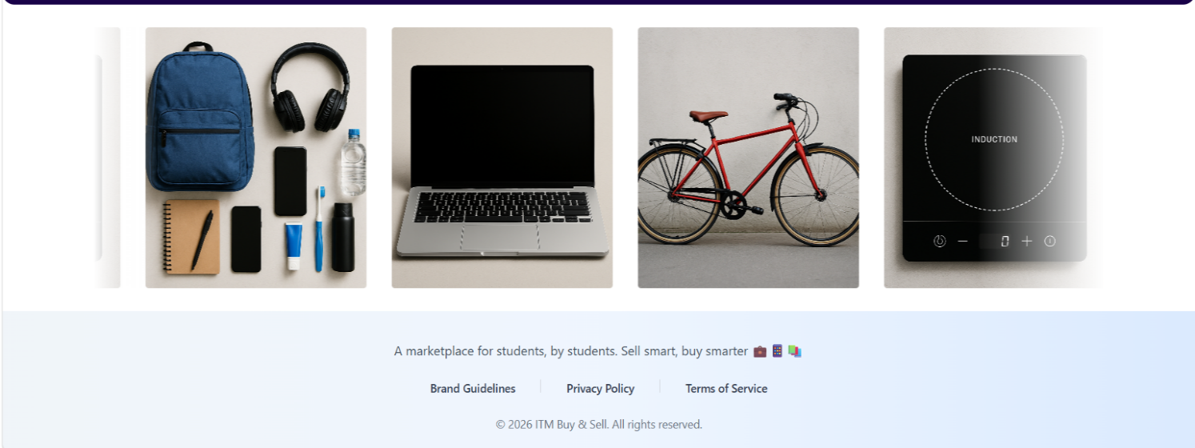

17

7.2 REGISTERATION PAGE

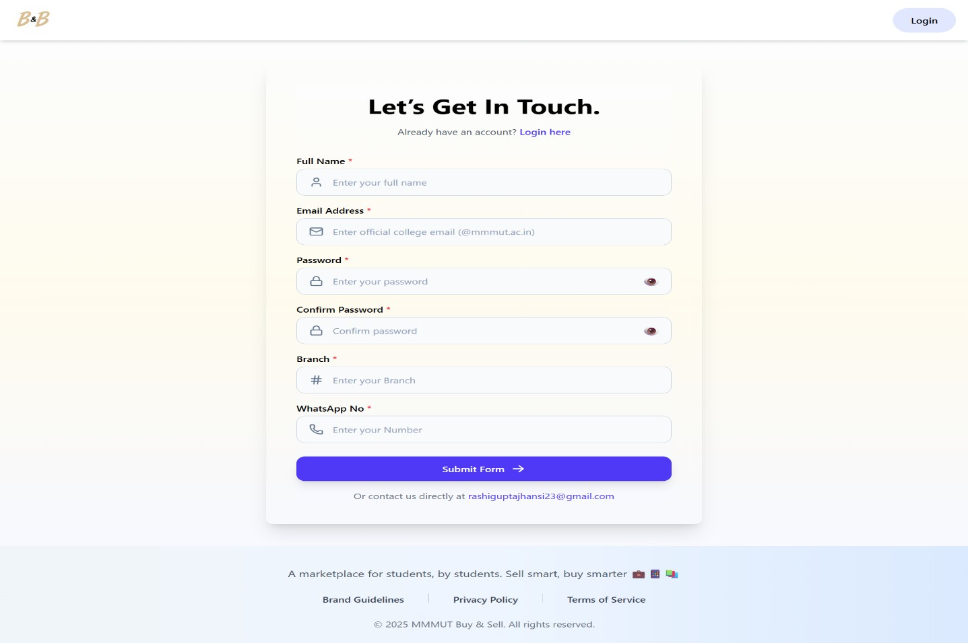

7.3 LOGIN PAGE

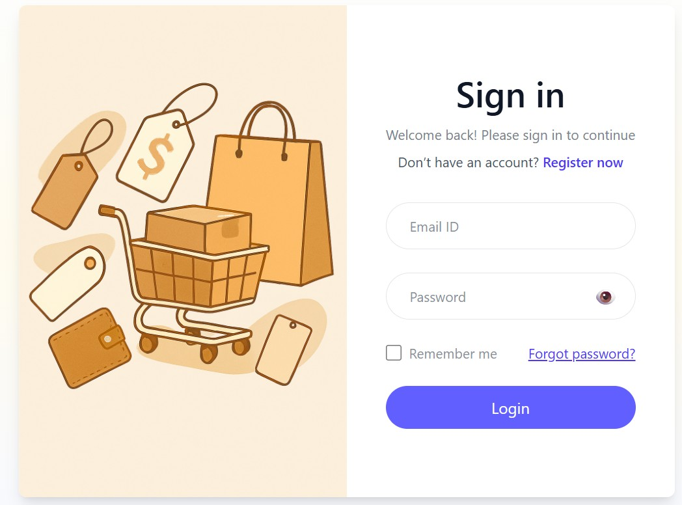

Screens Displayed After Successful Login

18

7.4 Home Page

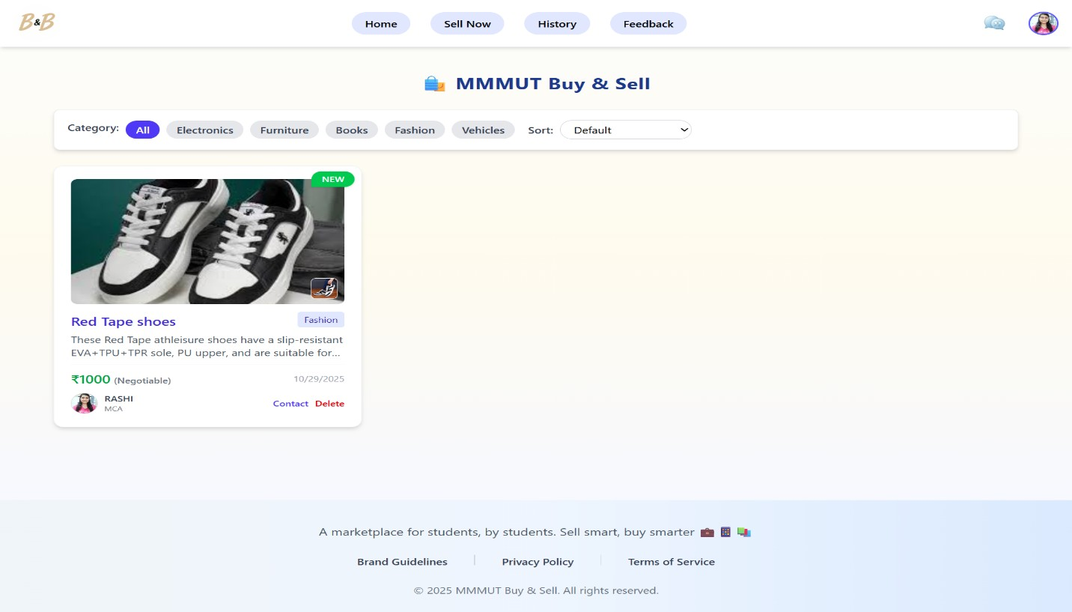

7.5 Feedback Page

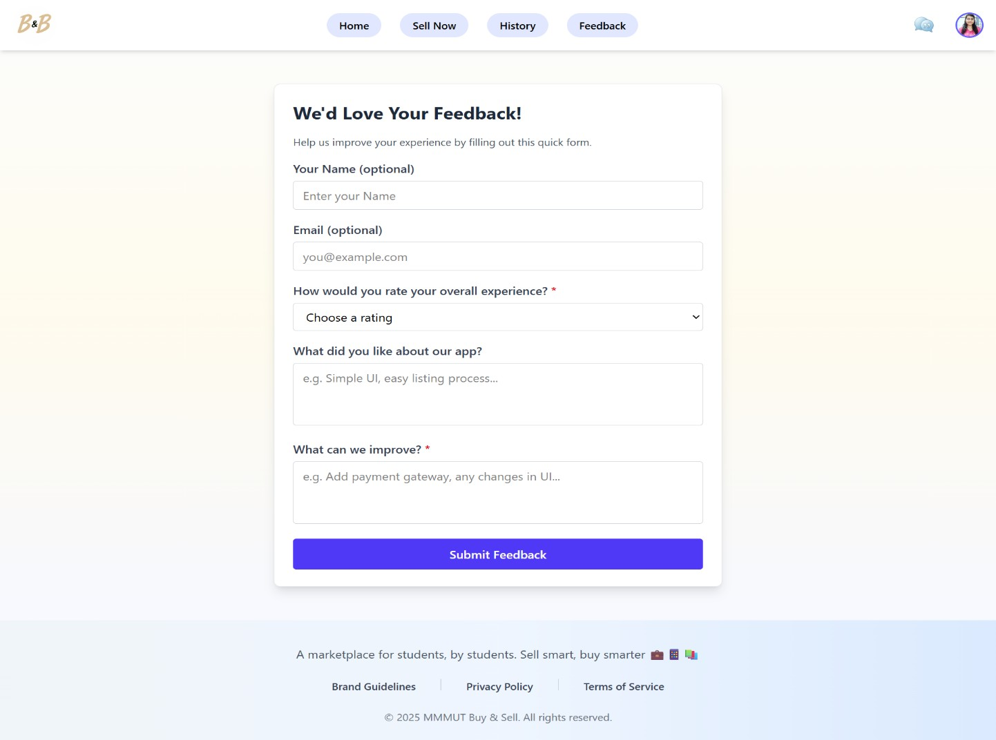

19

7.6 Sell Page

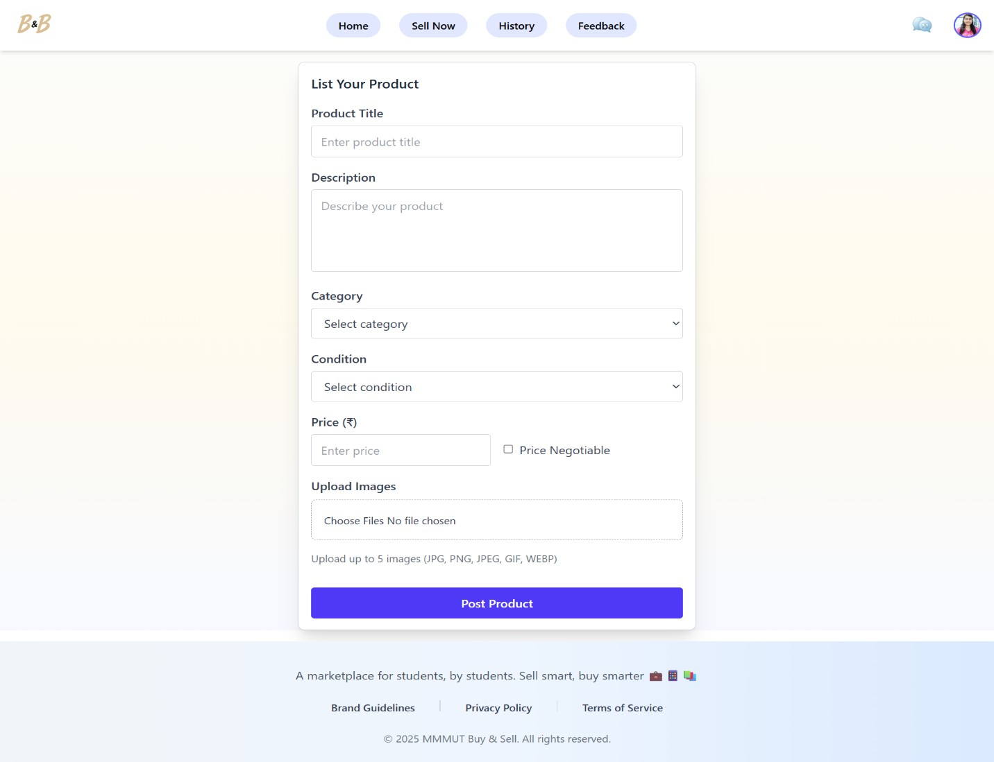

7.7 History page

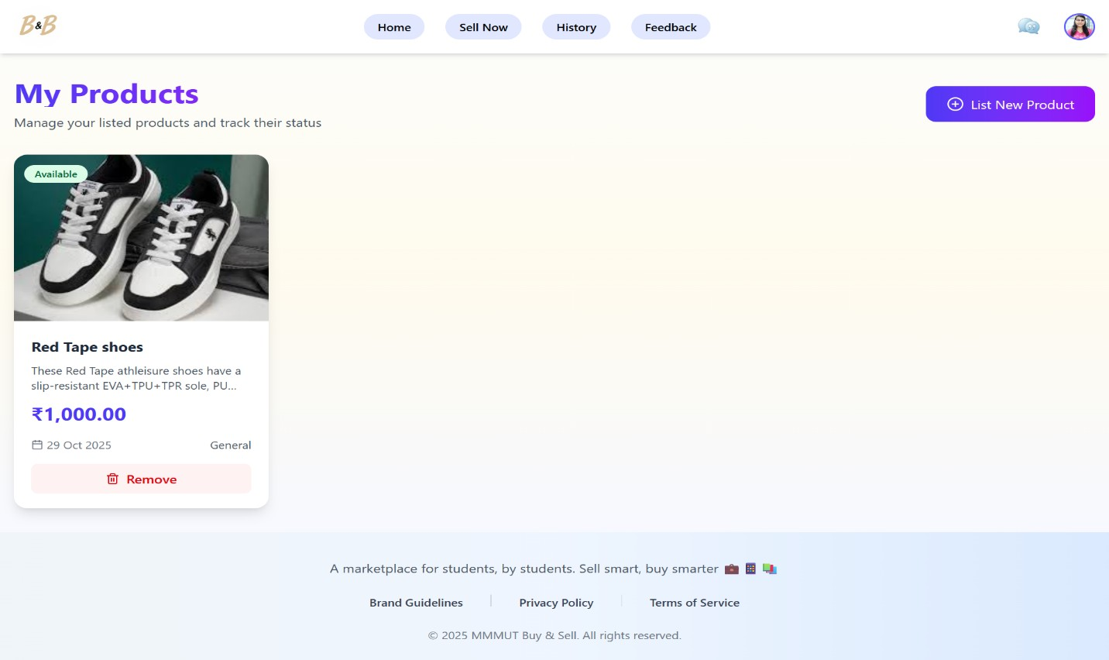

20
Chapter – 8
Results and Discussions

8.1 Results

The proposed system Buy & Blast was successfully designed, developed, and implemented using modern full-stack technologies. The system was tested under various conditions to evaluate its functionality, performance, and reliability. The results demonstrate that the application meets the intended objectives and provides a smooth and efficient platform for online buying and selling.
The user authentication module was implemented using secure mechanisms, allowing users to register and log in with proper validation. The system ensures that only authorized users can access specific features, thereby maintaining data privacy and security. During testing, the authentication process worked accurately for both valid and invalid inputs, providing appropriate responses and error messages.
The product management module performed effectively, enabling users to add new products, update existing listings, and delete products when required. The image upload feature was integrated with cloud storage services, ensuring efficient handling and retrieval of media files. All product-related data was stored and managed properly in the database, demonstrating consistency and reliability.
One of the major highlights of the system is the real-time chat functionality. The implementation of web socket technology allowed users to send and receive messages instantly without refreshing the page. This feature significantly enhanced user interaction and improved the overall usability of the system. Testing results showed that messages were delivered quickly and accurately, even when multiple users were active simultaneously.
The email notification feature was also tested successfully using mailing services.
Users received emails for specific actions,confirming that the system can effectively communicate important updates. The frontend interface, developed using modern frameworks, provided a responsive and interactive user experience across different devices and screen sizes.
The backend APIs handled requests efficiently, ensuring smooth communication between the frontend and the database. The system maintained good performance with minimal response time under normal usage conditions. Overall, the results indicate that the system is stable, functional, and capable of handling the core requirements of an online marketplace.

21
8.2 System Testing

A comprehensive testing process was carried out to ensure the correctness, efficiency, and reliability of the system. Different types of testing methodologies were applied throughout the development lifecycle.
Unit testing was performed on individual modules such as user authentication, product management, chat system, and email functionality. Each module was tested independently to verify that it performs its intended function correctly. The results confirmed that all modules were working as expected.
Integration testing was conducted to ensure proper interaction between different components of the system. The communication between frontend and backend, as well as between the server and database, was tested thoroughly. The system successfully handled data exchange without any inconsistencies or failures.
Manual testing was used to evaluate the user interface and overall user experience. Various scenarios were tested, including user registration, login, product upload, messaging, and logout. The system responded correctly in all cases, providing a smooth and intuitive experience.

Error handling and validation were also tested by providing invalid inputs such as incorrect login credentials, missing fields, and invalid data formats. The system displayed appropriate error messages and prevented incorrect data from being processed, ensuring robustness and reliability.

8.3 Performance Evaluation

The performance of the system was evaluated based on response time, data handling capability, and real-time communication efficiency. The application demonstrated quick response times for most operations, such as loading pages, fetching product data, and sending messages.
The use of efficient database queries and optimized backend logic contributed to smooth system performance. The real-time chat system showed minimal delay in message delivery, indicating effective implementation of web socket technology. The system was able to handle multiple user interactions simultaneously without significant performance degradation.
However, it was observed that performance may be affected under poor network conditions, especially for real-time communication. Despite this, the system maintained acceptable performance levels under normal usage scenarios.

22
8.4 Discussion

The results clearly indicate that the proposed system successfully integrates marketplace functionality with real-time communication, addressing the limitations identified in existing systems. The inclusion of instant chat significantly improves user interaction, allowing buyers and sellers to communicate directly and make informed decisions.
The use of modern technologies such as a responsive frontend framework, efficient backend architecture, and cloud-based services enhances the overall performance and scalability of the system. Secure authentication mechanisms ensure data protection, while proper validation techniques maintain data integrity.
The system provides a user-friendly interface that simplifies navigation and improves accessibility. Features such as product management, image upload, and messaging are well integrated, creating a seamless user experience.
Despite its strengths, the system has certain limitations. The absence of an integrated payment gateway restricts transactions to external methods. Additionally, the system relies on internet connectivity, and performance may vary depending on network conditions. These limitations can be addressed in future enhancements.

8.5 Comparison with Existing Systems

When compared to existing online marketplace systems, the proposed system offers a more integrated and interactive solution. Many traditional platforms focus primarily on product listing and transactions, while communication between users is limited or delayed.
In contrast, the proposed system combines marketplace features with real-time chat, providing a more engaging and efficient platform. The use of modern UI design, secure authentication, and cloud integration further distinguishes it from existing systems. This combination of features results in improved user satisfaction and better overall performance.

23
Chapter – 9
Future Scope

The proposed system Buy & Blast establishes a solid platform for online buying and selling with integrated real-time communication. Although the current system successfully fulfills its primary objectives, there is significant scope for further enhancement to make it more advanced, scalable, and competitive with modern e-commerce platforms.
One of the most important future improvements is the integration of a secure and seamless online payment system. Incorporating multiple payment options such as UPI, net banking, credit/debit cards, and digital wallets would allow users to complete transactions directly within the platform. Additionally, features like payment history, transaction tracking, and refund management can be included to enhance user trust and convenience.
Another major area of expansion is the development of dedicated mobile applications for Android and iOS. While the current web application is responsive, a mobile app would provide a smoother user experience, better performance, and features such as push notifications and offline support. This would significantly increase user engagement and accessibility.
The system can also be enhanced by integrating artificial intelligence and machine learning techniques. These technologies can be used to implement personalized product recommendations, smart search results, and user behavior analysis. Such features would not only improve user satisfaction but also increase the efficiency of the platform by helping users find relevant products quickly.
In terms of communication, the platform can be extended to support advanced messaging features such as voice notes, video calls, file sharing, and real-time notifications. This would make the interaction between buyers and sellers more effective and closer to real-life communication, thereby improving trust and transparency.
Security enhancements are another important aspect of future development. The system can implement multi-factor authentication (MFA), end-to-end encryption for chat messages, and advanced fraud detection mechanisms. User verification processes, such as email/phone verification and identity validation, can also be added to ensure the authenticity of users and reduce the risk of fraudulent activities.
Scalability and performance can be improved by adopting cloud computing technologies and microservices architecture. Deploying the system on cloud platforms with load balancing and auto-scaling features would enable it to handle a large number of users and high traffic efficiently. This would ensure better reliability, availability, and faster response times.

24
Furthermore, the platform can be expanded by adding new features such as product reviews and ratings, seller feedback systems, wishlist functionality, order tracking, and category-based browsing. Integration with social media platforms would allow users to share products easily, increasing the reach and popularity of the platform.
Another potential enhancement is the inclusion of an admin dashboard with analytics and reporting tools. This would help in monitoring user activity, managing products, tracking system performance, and making data-driven decisions for further improvements.
In the long term, the project can evolve into a complete e-commerce ecosystem, supporting multiple vendors, business accounts, advertisements, and promotional tools. This would transform the platform from a simple marketplace into a fully functional and commercially viable application.
Overall, the future scope of the project lies in continuously enhancing its features, improving user experience, strengthening security, and expanding its capabilities to meet the growing demands of digital commerce and modern users.

25

Chapter - 10
Conclusion

The ITM University Buy & Sell Platform represents a significant step toward digitizing the on-campus marketplace at ITM University, Gwalior. It provides a secure, efficient, and community-oriented solution for students to exchange goods and services within a trusted environment. By addressing issues such as safety, affordability, and accessibility, this project bridges the gap between online convenience and campus credibility.

The system has been meticulously designed using modern web technologies like the MERN stack (MongoDB, Express.js, React.js, and Node.js), ensuring flexibility, scalability, and maintainability. The backend handles data management, authentication, and server-side operations securely through JWT-based tokens and encrypted password storage, while the frontend offers an intuitive, responsive interface with features like real-time chat, OTP verification, and product filtering. Together, these technologies create a seamless user experience that aligns with the expectations of digitally proficient university students.

Throughout the project’s development, emphasis was placed on user-centric design and security. Restricting access exclusively to verified ITM University email IDs establishes a controlled digital community, minimizing the risk of fraudulent activity. Features like OTP verification, product reporting, and admin moderation maintain transparency and ensure that the marketplace remains clean and reliable.

The platform’s real-time communication system powered by Socket.io enhances interaction among users, while integration with Cloudinary ensures fast and efficient image handling.
Every technical choice was made to balance performance, costefficiency, and ease of maintenance. The database schema has been normalized for efficient data retrieval and scalability, ensuring that the system can handle a growing user base in the future.
Beyond technical implementation, the project carries broader social and environmental implications. By enabling students to sell and purchase used items, the platform promotes sustainability and resource sharing, reducing unnecessary waste and encouraging a culture of reuse within the campus. It also provides a cost-effective solution for students who may not afford new materials or gadgets.

26
From an academic perspective, the ITM University Buy & Sell
Platform demonstrates the application of multiple disciplines within computer science — including database design, web development, cybersecurity, and software engineering methodologies. The project adheres to systematic development practices, from requirement analysis and system design to testing and deployment. Testing through both automated and manual methods ensured the reliability and performance of all modules, while user acceptance feedback confirmed its practicality and ease of use.
In conclusion, the ITM University Buy & Sell Platform successfully fulfills its mission to create a safe, accessible, and efficient campus marketplace. It reflects the growing importance of digital transformation within educational institutions and sets a foundation for future innovation. With continuous development and the implementation of upcoming enhancements such as payment integration, AI-based recommendations, and mobile support, the platform can become an indispensable part of campus life. It stands as a testament to how technology, when applied thoughtfully, can bring a tangible positive impact to the student community — empowering them to connect, collaborate, and trade responsibly within their own academic environment.

27

References

1. Tilkov, S., & Vinoski, S. (2010). Node.js: Using JavaScript to Build High-Performance Network Programs. IEEE Internet Computing.

2. OpenJS Foundation. (2024). Node.js Official Documentation. Available: https://nodejs.org/

3. Express.js. (2024). Express Web Framework Documentation. Available: https://expressjs.com/

4. MongoDB Inc. (2024). MongoDB Documentation. Available: https://www.mongodb.com/docs/

5. React Team. (2024). React Official Documentation. Available: https://react.dev/

6. Redux Toolkit Team. (2024). Redux Toolkit Documentation. Available: https://redux-toolkit.js.org/

7. Fette, I., & Melnikov, A. (2011). The WebSocket Protocol. IETF RFC 6455.

8. Socket.IO. (2024). Socket.IO Documentation. Available: https://socket.io/docs/

9. Nodemailer Community. (2024). Nodemailer Documentation.

Available: https://nodemailer.com/about/

10. Cloudinary Inc. (2024). Cloudinary Documentation.

Available: https://cloudinary.com/documentation

11. Mozilla Developer Network (MDN). (2024). Web Development Technologies. Available: https://developer.mozilla.org/

12. Fielding, R. T. (2000). Architectural Styles and the Design of Network-based Software Architectures (REST). University of California.

13. Rescorla, E. (2000). HTTP Over TLS (HTTPS). IETF

.
28

